Is my child too ill for school?

LANGWITH BASSETT JUNIOR ACADEMY
  - Last revised January 2023

Introduction

It can be tricky deciding whether or not to keep your child off school or nursery when they're unwell.

There are government guidelines for schools and nurseries about managing specific infectious diseases at GOV.UK. These say when children should be kept off school and when they shouldn't.

If you do need to keep your child at home, it's important to phone the academy office, let us know that your child won't be in and give us the reason.

If your child is well enough to go to school but has an infection that could be passed on, such as a cold sore or head lice, please let us know.

Sometime children may feel unwell but there may be no specific illness or apparent cause. In these cases, it is important to send your child to school and we will happily monitor the situation throughout the day, sending them home if needed.

If a child presents with any of these symptoms whilst in attendance at the academy, then we follow the same advice. You would be asked to collect your child for any incidences of vomiting and /or diarrhoea, unexplained rashes, severe headache, or any illness or injury that may need to be checked by a health professional.

Coronavirus
Children with mild COVID symptoms can attend school, although they should remain at home if they have a high temperature.

COVID testing is no longer recommended for children, but if they have tested positive they should stay away from school for 3 days. If someone else they have contact with tests positive but the child is well, they can still attend.

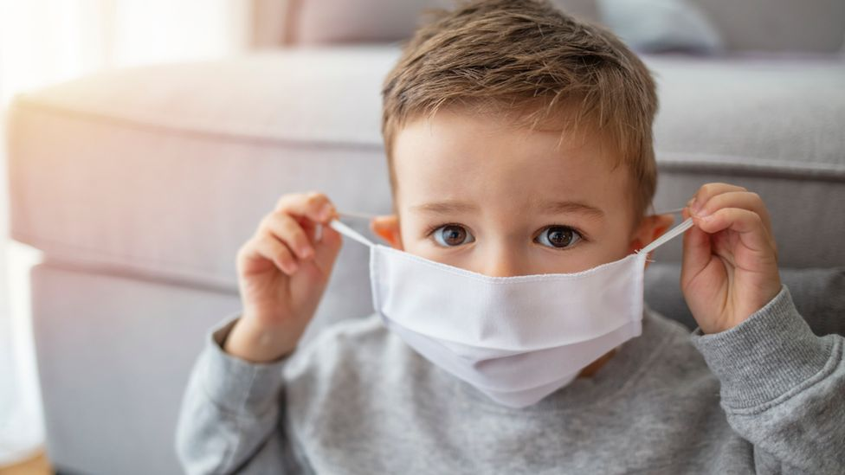

CATCH IT, BIN IT, KILL IT

Other illnesses

Follow this advice if your child does not have coronavirus symptoms or they had a test and it was negative (they do not have coronavirus).

Coughs and colds
It's fine to send your child to school with a minor cough or common cold. But if they have a fever, keep them off school until the fever goes.

Encourage your child to throw away any used tissues and to wash their hands regularly.

High temperature or fever
If your child has a high temperature, of 38C or above keep them off school until it goes away.

Chickenpox
If your child has chickenpox, keep them off school until all the spots have crusted over.

This is usually about 5 days after the spots first appeared.
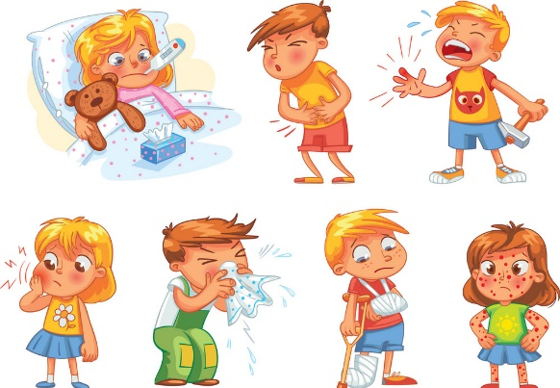

Cold sores
There's no need to keep your child off school if they have a cold sore.

Encourage them not to touch the blister or kiss anyone while they have the cold sore, or to share things like cups and towels.

Conjunctivitis
You don't need to keep your child away from school if they have conjunctivitis.

Do get advice from your pharmacist. Encourage your child not to rub their eyes and to wash their hands regularly.

Ear infection
If your child has an ear infection and a high temperature or severe earache, keep them off school until they're feeling better or their high temperature goes away.

Hand, foot and mouth disease
If your child has hand, foot and mouth disease but seems well enough to go to school, there's no need to keep them off.

Encourage your child to throw away any used tissues straight away and to wash their hands regularly.

Head lice and nits
There's no need to keep your child off school if they have head lice. You can treat head lice and nits without seeing a GP.

Impetigo
If your child has impetigo, they'll need treatment from a GP, often with antibiotics.

Keep them off school until all the sores have crusted over and healed, or for 48 hours after they start antibiotic treatment.

Encourage your child to wash their hands regularly and not to share things like towels and cups with other children at school.

Ringworm
If your child has ringworm, see your pharmacist unless it's on their scalp, in which case you should see a GP.

It's fine for your child to go to school once they have started treatment.

Scarlet fever
If your child has scarlet fever, they'll need treatment with antibiotics from a GP. Otherwise they'll be infectious for 2 to 3 weeks.

Your child can go back to school 24 hours after starting antibiotics.

Slapped cheek syndrome
You don't need to keep your child off school if they have slapped cheek syndrome, because once the rash appears, they're no longer infectious.

If you suspect your child has slapped cheek syndrome, take them to see a GP and let their school know if they're diagnosed with it.

Sore throat
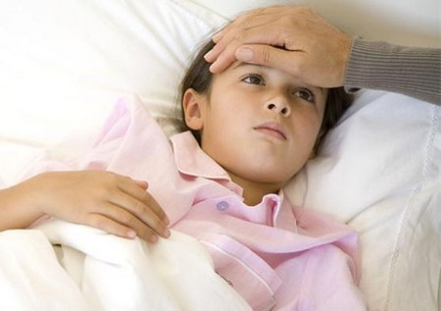
You can still send your child to school if they have a sore throat. But if they also have a high temperature, they should stay at home until it goes away.

A sore throat and a high temperature can be symptoms of tonsillitis.

Threadworms
You don't need to keep your child off school if they have threadworms.

Speak to your pharmacist, who can recommend a treatment.

Vomiting and diarrhoea
Children with diarrhoea or vomiting should stay away from school for 2 days after their symptoms have gone.

ANY QUESTIONS?

Please feel free to contact your child’s teacher, Mrs Bacon or Miss Bowring if you require any more information about whether your child should attend the academy. We are always happy to help.

CONTACT US

Langwith Bassett Junior Academy
Phone: 01623 742236
Email: info@langwithbassettacademy.org
Web: www.langwithbassettacademy.org



