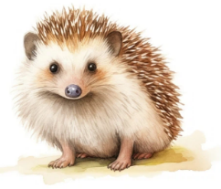
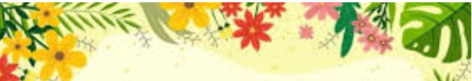
Summer Term 1

Year 3 and 4
English  ‘The Selfish Giant’ and ‘The Happy Prince’  The children will study the language, plot, structure and characters of the beloved stories ‘The Selfish Giant’ and ‘The Happy Prince’ by Oscar Wilde. They will make connections with themes, morals and philosophical questions on a personal level which will enrich their understanding of the story and help them to produce thoughtful, meaningful writing. With a clear focus on the effect on purpose and audience, the teaching of grammatical structures and vocabulary is embedded in the reading and writing and pupils will explore how these create effects in the story then apply them to their own writing. The unit culminates in a final piece of writing where pupils can use all of the knowledge and skills they have learned to write a traditional tale of their own  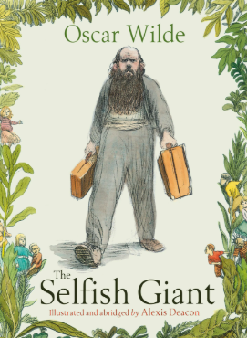 | Science  Light  The children will learn about light and how it helps us see. They will explore natural and artificial light sources, understand how light travels in straight lines, and see how shadows are formed and change shape. Through simple experiments, they will observe, question, and record their findings, building their scientific skills.  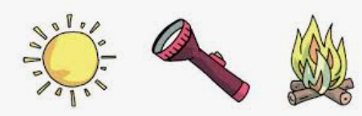 | Maths  This half-term the children will learn to add and subtract fractions, helping them understand parts of a whole. They will investigate mass and capacity, measuring and comparing different amounts and will also begin to explore decimals to connect fractions with decimal numbers. Through practical activities, they will develop problem-solving and reasoning skills in everyday contexts.  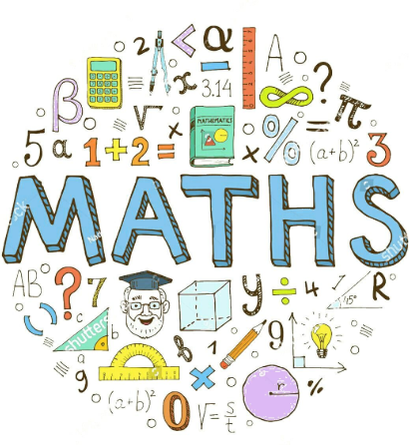
Spelling  Children will have spelling lessons every Monday where they will learn a new spelling rule. They will be given activities through the week to practise this rule and will have a spelling test the following Monday.  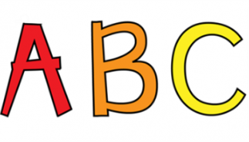  Handwriting & Letter Formation  As a school, we have a real focus on handwriting this year and will have regular handwriting practise in order to learn and practise forming letters and joining correctly. | PE  ‘Football and Swimming’  On Tuesday afternoons the children will have an athletics lesson. Please ensure children have full indoor and outdoor PE kits.  See planner for correct PE kits.  Children will have swimming lessons on a Thursday afternoon – please make sure children have their swimming costumes, a towel, hair bobbles for long hair and hairbrush.  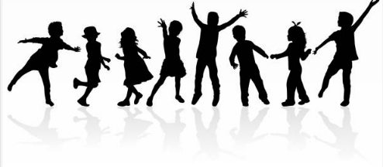 | RSHE  The themes that we will be covering this half term are:  Personal Information  Online strangers  Sharing online  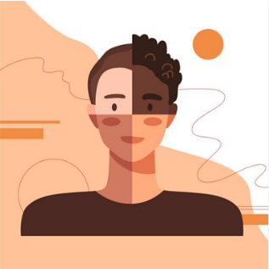  RE  The children will be exploring what Christians learn from the creation story.
Geography  What’s beneath our feet?  Children will learn about what lies beneath our feet, revisiting the layers of the Earth. They will also study earthquakes, how they happen, and their effects on people and places. Through maps, diagrams and discussions, children will develop their understanding of the Earth’s structure and natural disasters and the effects these can have on people. | Art  The children will be working with clay to create their own 3D models. They will also study the work of Patrick Caulfield, exploring how he uses shapes and textures in his art. Through hands-on projects, children will develop creativity, fine motor skills, and an understanding of 3D art. | Computing  Desktop Publishing  In computing the children will learn how to use desktop publishing, creating and designing documents using text, images and varied layouts. They will explore how to organize content effectively and use digital tools to communicate ideas clearly and creatively.  Music  Ukulele  Children will learn about rhythm and notation whilst taking part in ukelele lessons.

