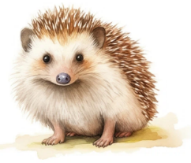
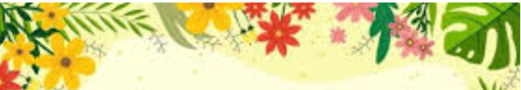
Autumn Term 1

Year 3 and 4
English  ‘Spelling, punctuation and grammar – SPaG’  This half term, we will focus on spelling, grammar and punctuation. Children will learn to identify and use different word classes effectively, explore what makes a good sentence, and develop their ability to use a variety of sentence structures. They will also practise using punctuation accurately and editing and improving their own writing. | Science  Electricity  This half term, children will learn about electricity and how electrical circuits work. They will identify common electrical components, build and test simple circuits, and explore what makes a bulb or buzzer work. Children will also investigate how changing components affects a circuit and learn about electrical safety in everyday life.  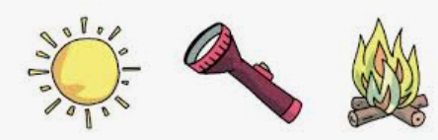 | Maths  Our focus, in Maths, this half term is the understanding of place value of numbers up to 10,000 for Year 4 and up to 1,000 for Year 3. Following this, children will combine their understanding of place value to add and subtract values using clear written methods.  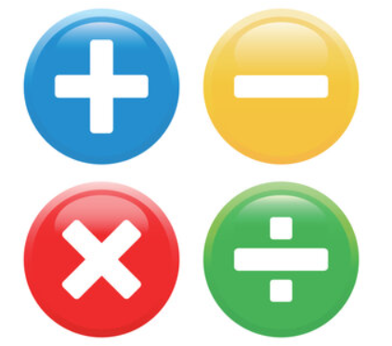  We will also be focusing on recalling multiplication facts up to 12 x 12..  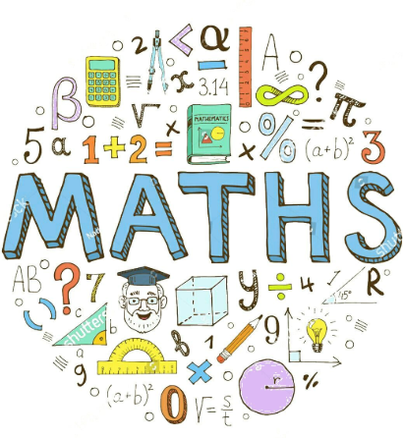
Spelling  Children will have regular spelling lessons throughout the week where they will learn a new spelling rule. They will be given activities through the week to practise this rule.  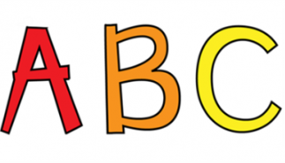  Handwriting & Letter Formation  As a school, we have a real focus on handwriting this year and will have regular handwriting practise in order to learn and practise forming letters and joining correctly. | PE  ‘Netball and Tennis  On Tuesday afternoons the children will have a netball skills lesson. Children will have tennis lessons on a Thursday afternoon  Please ensure children have full indoor and outdoor PE kits. Please can you ensure children are not wearing jewellery and have tape to cover earrings if they can not yet be removed.   | RSHE  Our key questions that we will be covering this half term are: Are all friends the same? Are friendships always fun? Are we happy all the time?    RE  What kind of world did Jesus want?  This half term, children will explore what kind of world Jesus wanted and learn about the Christian values that guided his teachings. They will consider stories and teachings from the Bible and reflect on how values such as kindness, compassion, forgiveness, love and fairness can be shown in our own lives.
History  Romans  This half term, children will learn about the Romans and their impact on Britain. They will explore why the Romans invaded Britain, what life was like in Roman times, and how the Romans influenced our towns, roads, buildings and way of life. Children will also investigate important Roman figures and events and use evidence to develop their understanding of the past.  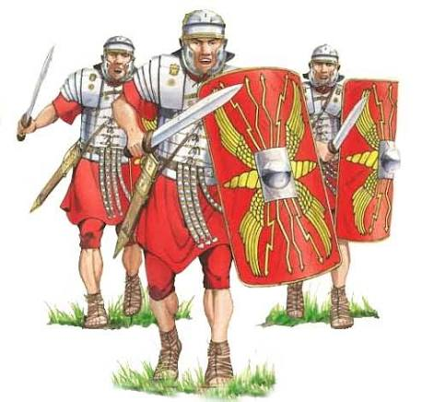 | Art  Portraits: Picasso  This half term, children will explore portraits and different styles of portraiture, focusing on the work of Pablo Picasso. They will investigate Cubism, experiment with shape, line, colour and shading, and create their own Cubist-inspired portraits.  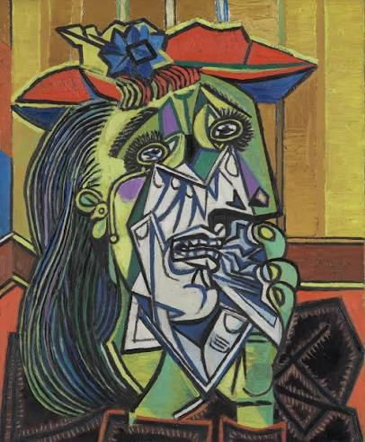 | Computing  The Internet  This half term, children will learn how the internet works and how information is shared online. They will explore networks, websites and search engines, and learn how to find and evaluate information effectively. Children will also develop their understanding of online safety, including how to communicate responsibly and stay safe when using the internet.  Music  Ukulele  Children will learn about rhythm and notation whilst taking part in ukelele lessons.

